**CREATING SMART WATER MANAGEMENT**

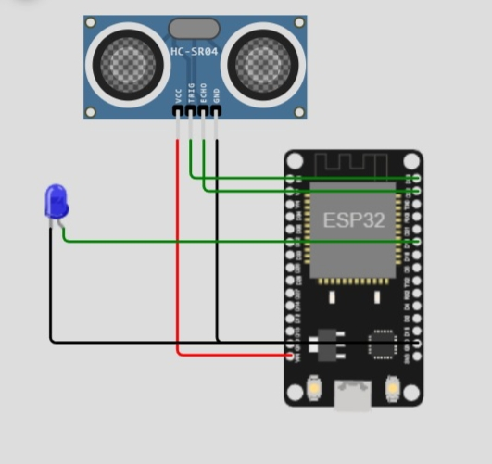

**SYSTEM FLOWCHART**

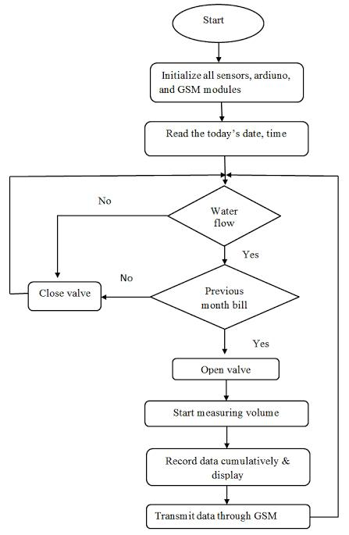

**SOURCE CODE**

Import machine

Import time

# Pin assignments for the ultrasonic sensor

TRIGGER_PIN = 23 # GPIO23 for trigger

ECHO_PIN = 22 # GPIO22 for echo

# Pin assignment for the LED

LEAK_LED_PIN = 19 # GPIO19 for the LED

# Set the pin modes

Trigger = machine.Pin(TRIGGER_PIN, machine.Pin.OUT)

Echo = machine.Pin(ECHO_PIN, machine.Pin.IN)

Leak_led = machine.Pin(LEAK_LED_PIN, machine.Pin.OUT)

# Function to measure distance using the ultrasonic sensor

Def measure_distance():

# Generate a short trigger pulse

Trigger.value(0)

Time.sleep_us(5)

Trigger.value(1)

Time.sleep_us(10)

Trigger.value(0)

# Measure the echo pulse duration to calculate distance

Pulse_start = pulse_end = 0

While echo.value() == 0:

Pulse_start = time.ticks_us()

While echo.value() == 1:

Pulse_end = time.ticks_us()

Pulse_duration = pulse_end – pulse_start

# Calculate distance in centimeters (assuming the speed of sound is 343 m/s)

Distance = (pulse_duration * 0.0343) / 2 # Divide by 2 for one-way travel

Return distance

# Function to check for a water leak

Def check_for_leak():

# Measure the distance from the ultrasonic sensor

Distance = measure_distance()

# Set the threshold distance for detecting a leak (adjust as needed)

Threshold_distance = 10 # Adjust this value based on your tank setup

If distance < threshold_distance:

# If the distance is less than the threshold, a leak is detected

Return True

Else:

Return False

# Main loop

While True:

If check_for_leak():

# Blink the LED to indicate a leak

Leak_led.value(1) # LED ON

Time.sleep(0.5)

Leak_led.value(0) # LED OFF

Time.sleep(0.5)

Else:

Leak_led.value(0) # LED OFF

Time.sleep(1) # Delay between measurements

This code monitors water flow using a flow sensor, calculates water usage, and sends an email notification when the usage exceeds a threshold. Please adapt and extend this code to your specific hardware and requirements for a complete smart water management system.